Courageous Characters:
With an emphasis on Characteristics
Kesha Prince

Analysis Document

Learning Goals
During this unit students will work to learn and develop knowledge of characters and character traits- even on an event basis. They will learn internal and external factors that help to determine how a person acts and the choices he or she makes. They will be able to differentiate character traits between people of different times in history and different genres of books. They will also be able to separate the knowledge of people character traits and historical, mathematical, and scientific traits.

The unit will also have an integration of the Revolutions in Social Studies, Shapes and Graphs in Math, and Microorganisms in Science- All pertaining to characteristics.

Needs Analysis
The curriculum map standards for 6th grade in Canyons School District includes the theme of Courageous Characters where students learn and discuss characteristics and attributes of courageous characters in History and pair it with related informational text from the same historical period. Their key terms include Character Development, so the students will be focusing on Character traits located in all parts of the curriculum based on characteristics.

Learner Analysis
The information is based on school demographics of the 2013-2014 school year. Classroom is based off of 6th grade classroom, 2013-2014 school year. English Language Arts, 2nd period.

Demographics
Indian Hills Middle School
Enrollment: 1096
Minority: 164
English Learners: .91%
Low Income: 17.88%
Special Education Services (Resource): 7.12%
Special Education Services (Self-Contained): 1.92%
Grade 6: 393
Grade 7: 350
Grade 8: 353
- My 6th grade classroom is total enrollment of 36. 44% Special Education Services (Resource). Demographics include: 83.33% White, 8.33% Hispanic-Latino, 0.00% American Indian, 5.56% Asian, 2.78% African/Black, 0.00% Pacific Islander, and 0.00% Multiracial. 20 of the classroom students are Male, 16 of the classroom students are Female.
- 14 students are Age 11
- 22 students are Age 12
- The school’s location is in Southeast Sandy, feeding in to Alta High School.
- 21 Weeks of School taught, school starting August 26th, ending June 4th.
- Most students in classroom are on time and present in class during regular classroom time.
- 6% of the students in my 2nd period report speaking Spanish in their home, 3% report speaking Chinese, and the remainder of the students speak English at home.

Attitudes, Values, and Opinions
- 69% of students have reported enjoying school on a 1-10 scale, 1 being poor and 10 being fantastic. (Enjoyment, choice of 5 or better)
- 48 % of students have reported to always turn in their work, 42% report usually turning their homework in, and 6% report sometimes turning their homework in. No students stated that they never turn their homework in.
- 18% of students reported preferring to work alone on schoolwork and projects, 51% prefer working with partners, and 30% prefer working in a group of 3 or more.
- 2 students are frequently absent, 1 student being gone 50% of the year so far and 1 student being gone 27% of the year.
- Class is a co-taught class, where a special-education teacher is in the classroom to supplement.

Access to Technology
97% of students report that they have access to a computer at home and 63% of those students report using the computer more than 4 times a week. Only 3% of the class, or 1 student, reports not having a computer at home, but still reported that they use the computer more than 4 times a week.

Schedules
English Language Arts is taught daily to all students for 60 minutes.
Learner Skills

- The graph below is of the 2012-2013, 5th grade CRT scores in the area of Language Arts. Every 6th grader that is currently enrolled at Indian Hills Middle School is included on this graph.
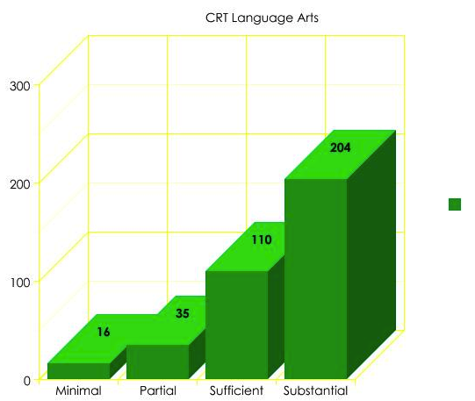

- Students were all tested in the Fall of 2013 with the R-CBM, which is a fluency test, counting of 1 minute for every student. Every 6th grader that is currently enrolled at Indian Hills Middle School is included on this graph.
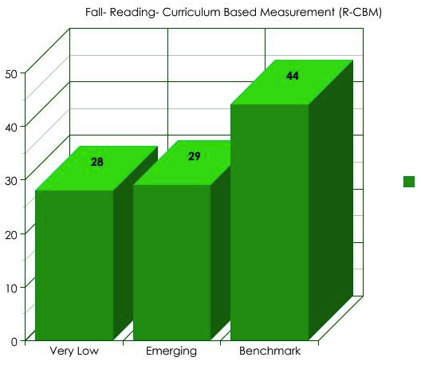

Task Analysis:

Embedded on Weebly website

Context for Instruction:

Resources available to use: teacher laptop, projector, Apple TV, teacher iPad, various reading material from science, math, and social studies. Mirrors and Windows Book, classroom set of Number the Stars (possibly), When my name was Keoko (Possibly), Ruby Bridges book.

Learner Objectives:
RI. 6.2 Determine a central idea of a text and how it is conveyed through particular details; provide a summary of the text distinct to personal opinions and judgments.

RL 6.3 Describe how a particular story or drama’s plot unfolds in a series of episodes as well as how the characters respond or change as the plot moves toward a resolution.

W 6.9 Draw evidence from literacy or informational texts to support analysis, reflection, and research.

W.6.8.Gather relevant information from multiple print and digital sources; assess the credibility of each source; and quote or paraphrase the data and conclusions of others while avoiding plagiarism and providing basic bibliographic information for sources

L 6.3 Use knowledge of language and its conventions when writing, speaking, reading, or listening.

